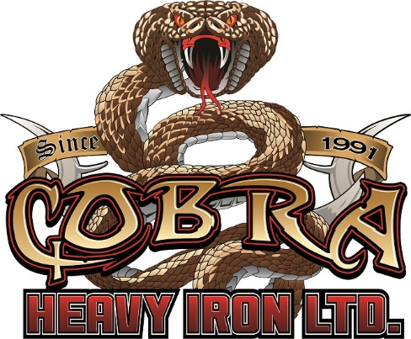

Cobra Heavy Iron is looking to add an administrative assistant to our team immediately. The successful applicant should have the following skills:

-team player
-multi-tasker
-organized
-able to follow instruction
-able to work within a deadline
-computer skills: keyboarding (40+ wpm) Microsoft word, excel, outlook
-A/P with Simply Accounting
-Adaptable to changing scope of work
-reliable
-class 5 drivers license
-exceptional work ethic

Job duties will include but not limited to:
- Billing
- Vehicle / equipment maintenance
- Safety (shop inspections / training tickets)
- A/P (matching invoices to statements)
- Fuel tracking
- Maintaining driver files
- Courses for safety

